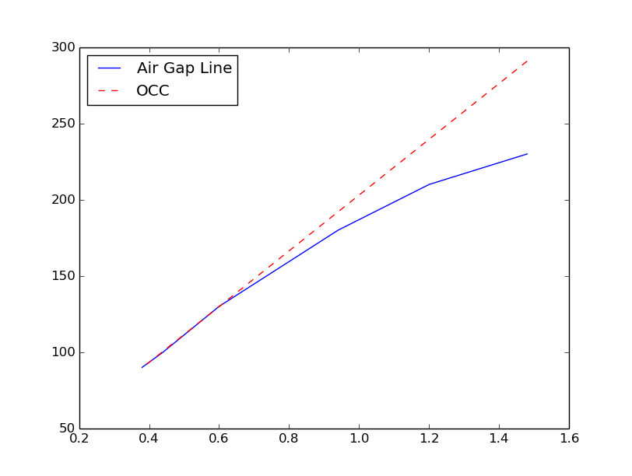
Open CirCuit Characteristic

Short Circuit Characterictic
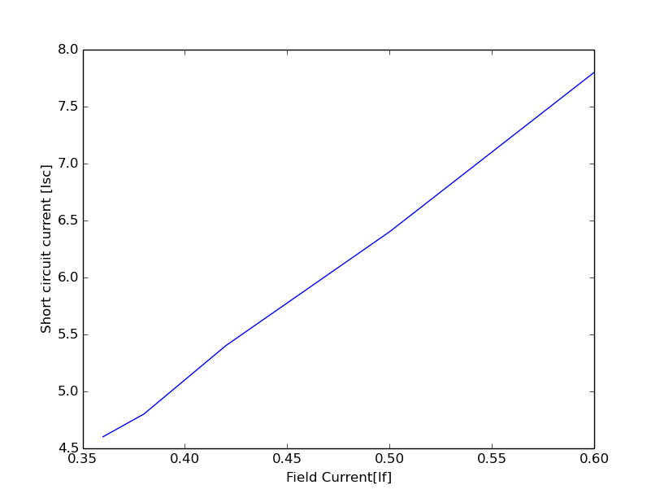
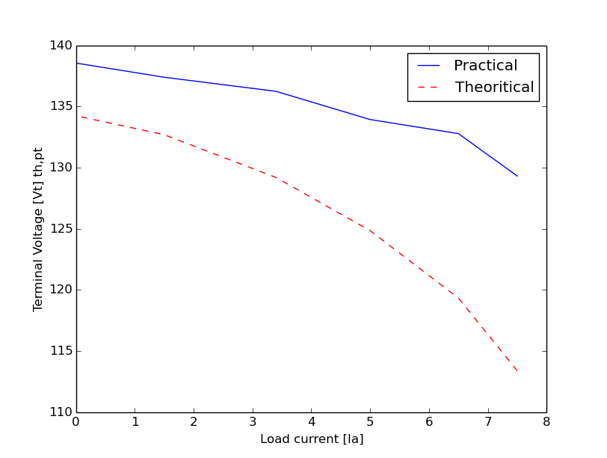
Load Characteristic-theoritical and practical

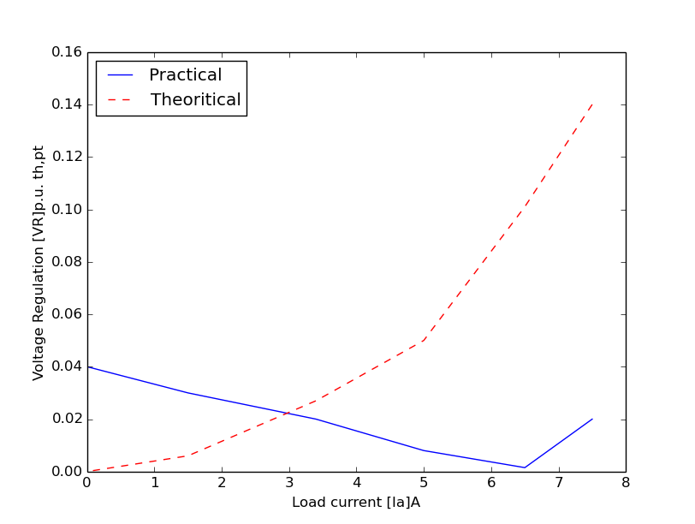
Voltage Regulation-Theoritical and Practical

